CSS 487 Final Technical Writeup

By Abd Elswify and Trevor Rosenstrom

12/09/2022

We sought to create a program that detects license plates and extracts relevant information from identified license plates. To accomplish this, we needed to utilize OpenCV methods that allow us to identify contours within an image while also excluding unnecessary information, further assisting in the detection of the license plates.

We accomplished this by first converting the image to grayscale and then applying bilateral/Gaussian filtering to remove noise and improve contrast. Next, we applied thresholding to the filtered image to highlight the edges of objects in the image. These steps resulted in an edge image that contained contours of various sizes.

We iterated through the contours in the edge image and added the ones with a rectangular shape to a sorted list based on their size. We then went through the ten largest contours and selected the one that was closest to a 1:2 aspect ratio, the typical ratio for a United States license plate. Once we located the contour most likely to be the license plate, we then drew it onto the original image and output the resulting image.

Throughout this project, we realized how important it is to find a balance when applying filters and thresholds to the image. Excessive filtering can blur the relevant contours of the objects in the image, making it too difficult to detect them. On the other hand, insufficient filtering can leave too much noise and again make it too difficult to distinguish the objects in the image.

We also learned that external factors, such as the angle and distance of the camera to the license plate, can affect the quality of the image and make it difficult to detect the license plate. In some cases, these factors can compromise the contour of the license plate before the program is even run, making it impossible to detect the license plate no matter what processing steps are applied.

Overall, this project has provided us with valuable experience working with OpenCV for image processing and computer vision tasks. We have gained a much better understanding of the challenges and limitations of license plate detecting programs.

The results of the project can be seen below:

* The output images that worked:

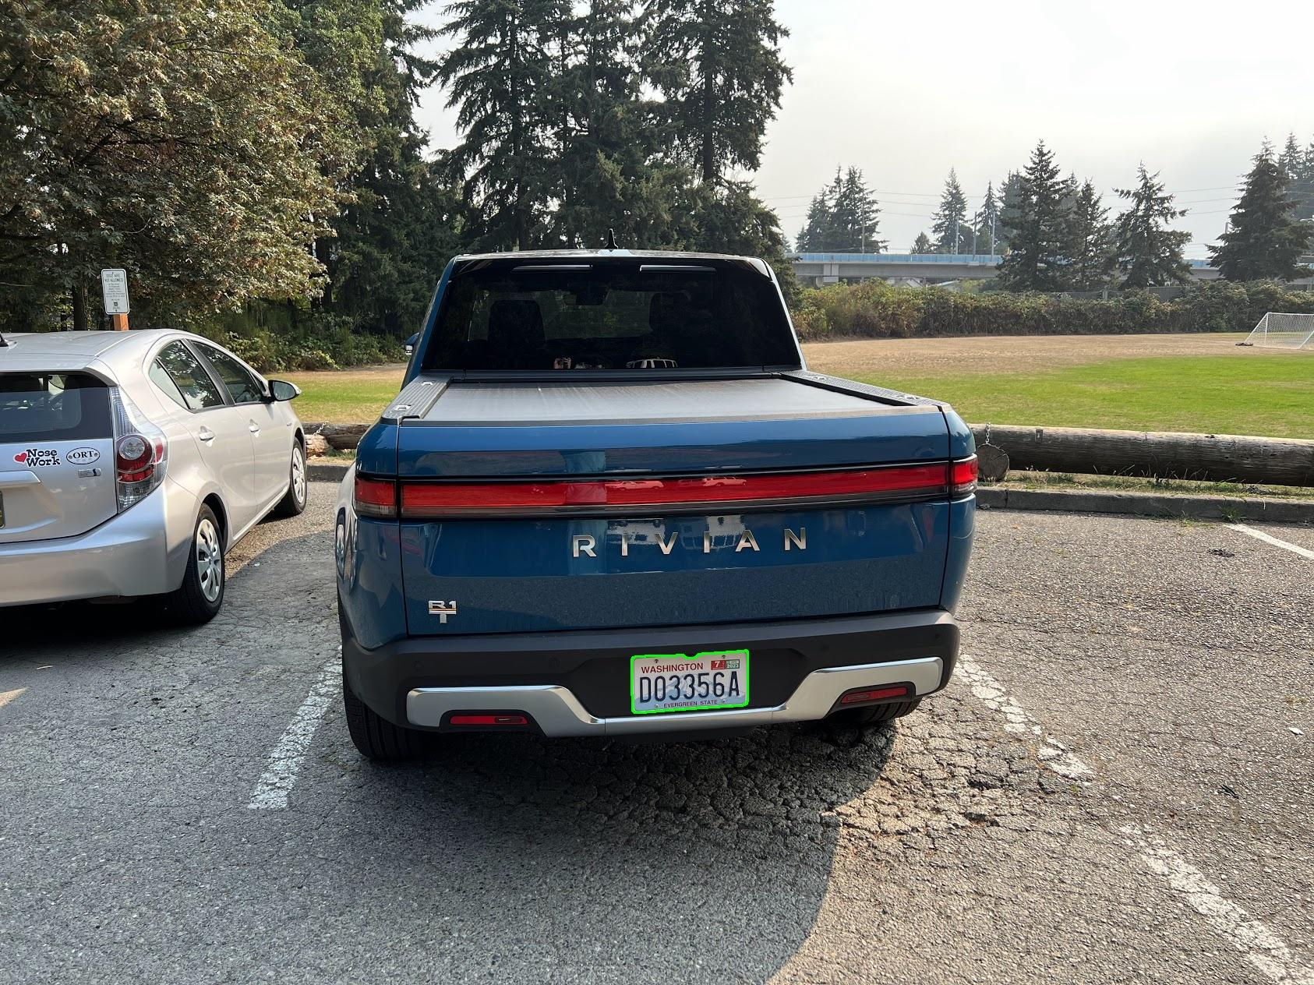

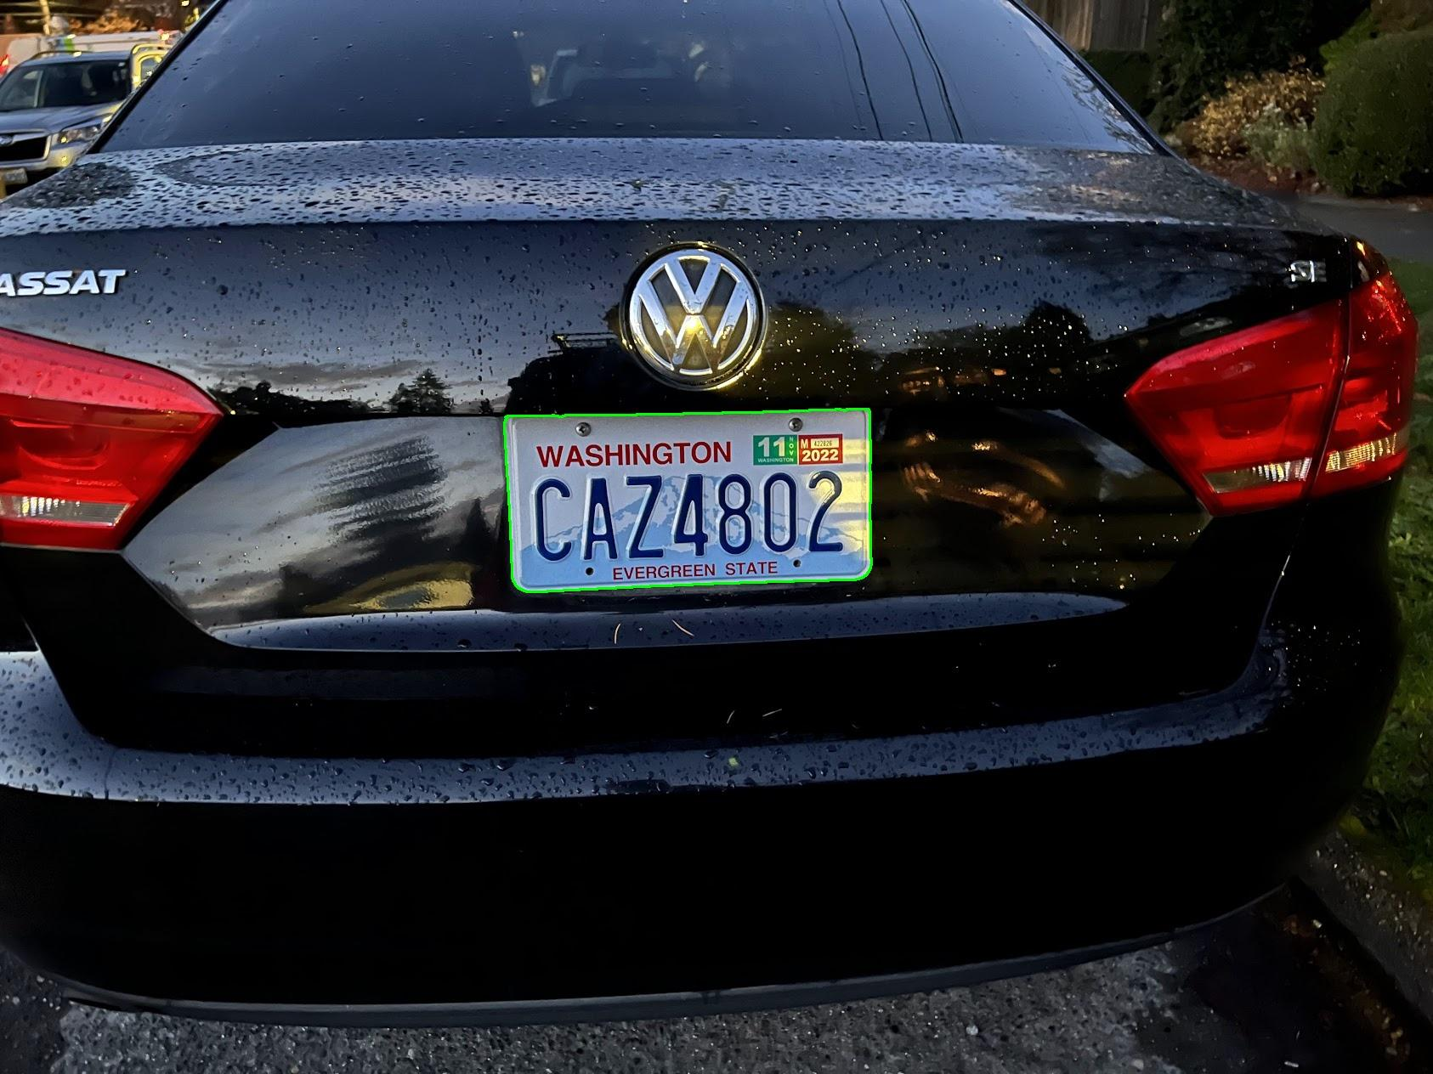

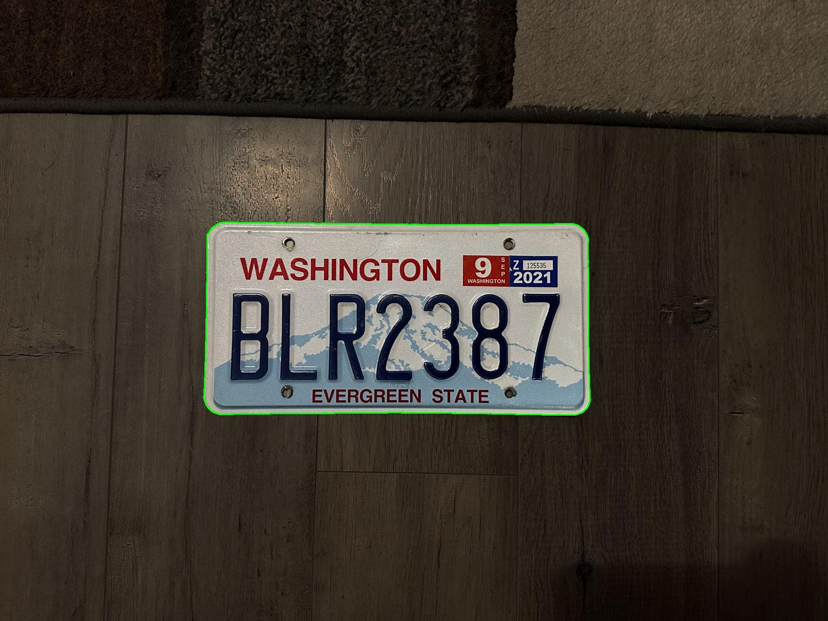

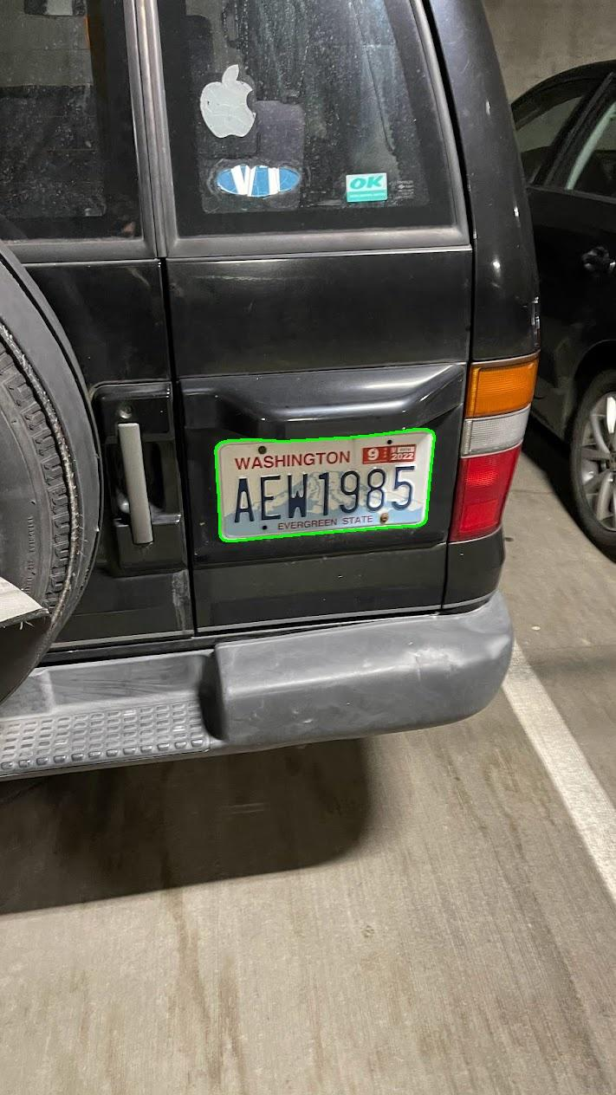

* The one that didn't work: